INSTALLATION OF PYTHON 3.11.0

|  |  |
| --- | --- |
| **Team ID** | PNT2022TMID15047 |
| **Project Name** | SMART WASTE MANAGEMENT SYSTEM FOR METROPOLITAN CITIES |

**STEP 1:**

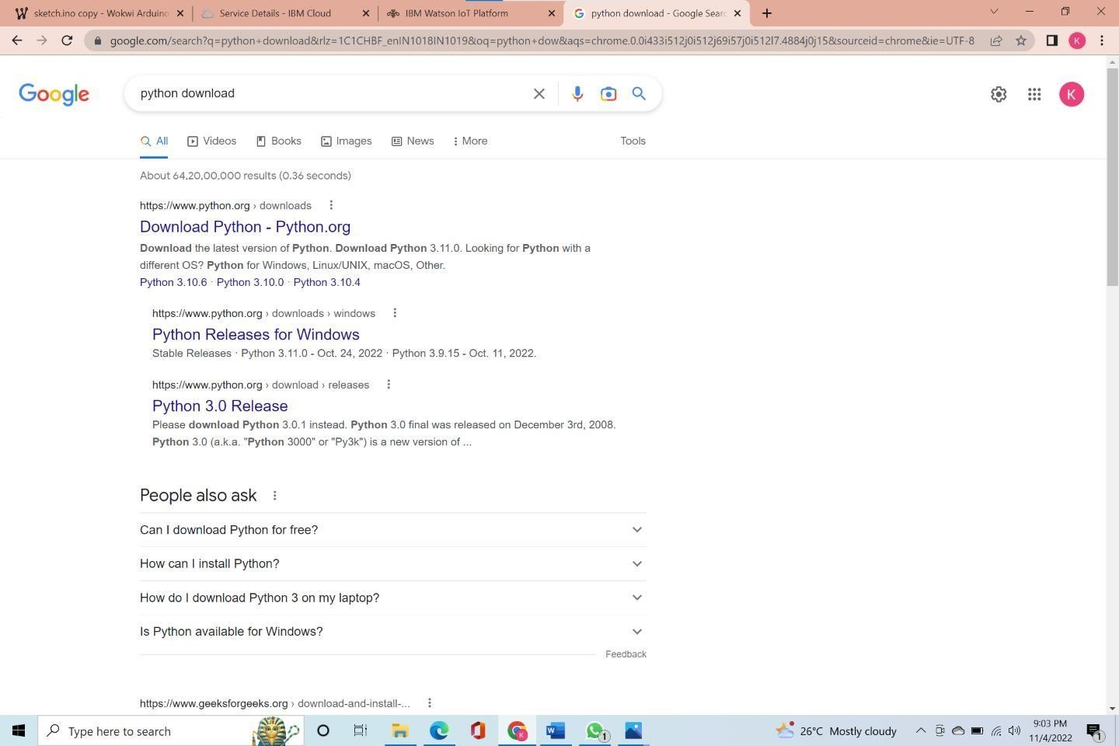

STEP 2:

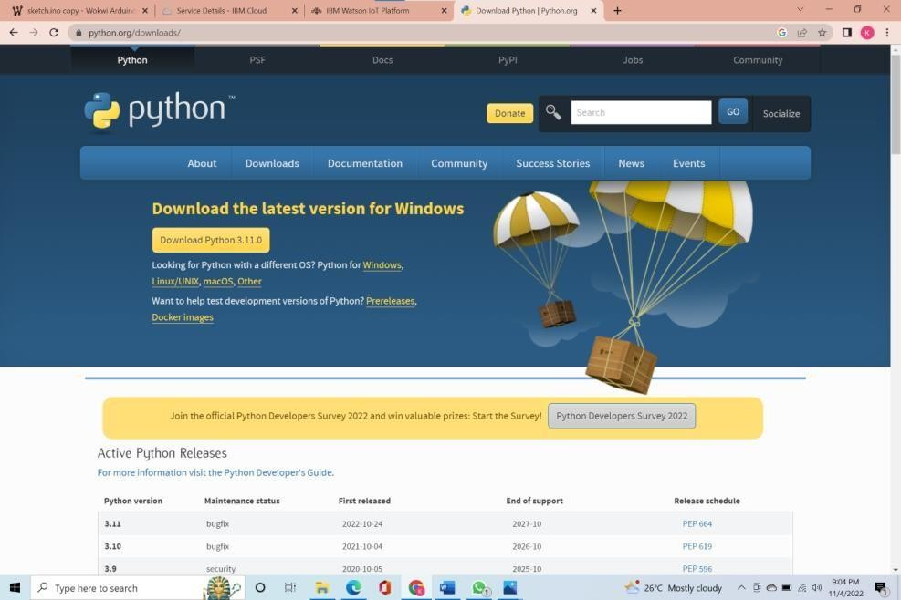

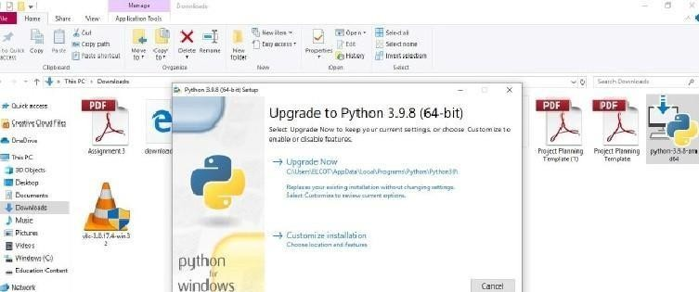STEP 3:

**Step 4:**

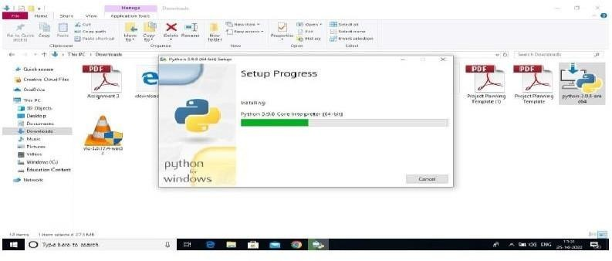

**Step 5:**

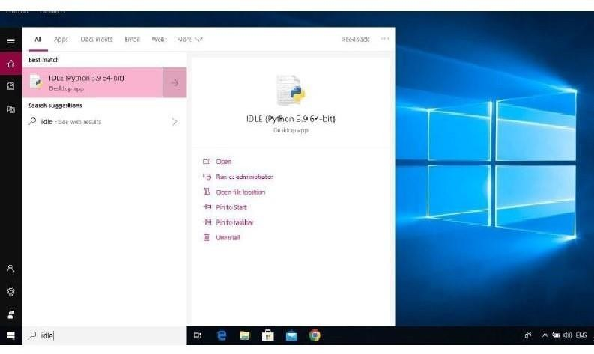

**Step 6:**

